# Lesson 46 单词讲解

1. unload v. 卸（货）

unload boxes unload passengers

load v. 装（货），放入

download / upload

1. occur v. 发生

sth. occur to sb. 某人(突然)想起某事

A good idea occurred to me.

= I suddenly got a good idea.

2. occur v. 发生

sth. occur to sb. 某人(突然)想起某事

To do sth occur to sb.

= It occurs/occurred to sb to do sth. 某人突然想去做某事

我突然想起来给我妈妈打个电话。

It occurs to me to call my mom.

1. occur v. 发生

sth. occur to sb. 某人(突然)想起某事

It occurs/occurred to sb to do sth. 某人突然想去做某事

It suddenly occurred to one of the workers to open up the box.

1. astonish v. 使 惊 讶be astonished at … 被。。弄得很惊讶

=be surprised at …

1. admit v. 承认

I’m wrong, and I admit it. admit doing sth.

The man admitted hiding in the box.

wooden ['wudn] a.木制的

3 extremely [ik'stri:mli] ad.非常，极其

4 occur [ə'kə:] v.发生

5 astonish [ə'stɔniʃ] v.使惊讶

6 pile [pail] n.堆

7 woollen ['wulən] n.羊毛的

8 goods [gudz] n.(常用复数)货物，商品

9 discover[dis'kʌvə] v.发现

10 admit [əd'mit] v.承认

11 confine [kən'fain] v.关在(一个狭小的空间里)

12 normal ['nɔ:məl] a.正常的，通常的

# Lesson 46 课文&语法讲解

本课重点:

同位语从句

doing / being done

介词后的宾语从句

1. When a plane from London arrived at Sydney airport, workers began to unload a number of wooden boxes which contained clothing.
2. No one could account for （解释）the fact that one of the boxes was extremely heavy.

同位语从句

含义：一个句子作同位语，解释说明前面名词位置：所解释的抽象名词后，

如 fact, news, theory, idea, suggestion, report … 写法：同宾语从句

（最常用的结构是 that + 完整的陈述句）

2. No one could account for the fact that one of the boxes was extremely heavy.

同位语从句

我毫不怀疑他将会帮我的忙。

I have no doubt that he will help me.

No one could account for the fact that one of the boxes was extremely heavy.

同位语从句

我支持这种观点，校车问题必须被严肃对待。

I support the argument .

I support the argument that the problems of school buses must be taken seriously.

1. No one could account for the fact that one of the boxes was extremely heavy.

同位语从句

含义：一个句子作同位语，解释说明前面名词位置：所解释的抽象名词后，

如 fact, news, theory, idea, suggestion, report … 写法：同宾语从句

（最常用的结构是 that + 完整的陈述句）

区别：

同位语从句

No one could account for the fact that one of the boxes was extremely heavy.

No one could account for the fact that rocked the world.

rocked the world.缺少主语,所以that做成分 是定于从句

定语从句

相同点:都跟在名词后。

不同点：同位语是解释说明这个名词的，定于从句是修饰这个名词的

如何分辨？关系词被省了（省了就是定语从句） 看名词是不是抽象的名词 看that做不做成分

1. It suddenly occurred to one of the workers to open up the box.

It occurs/occurred to sb to do sth.

某人突然想去做某事

1. He was astonished at what he found.

介词后的宾语从句

介词后的宾语从句

He was astonished at .



What did he find?

1. He was so surprised at being discovered that he did not even try to run away.

being discovered 表示被动了 整个句子不属于宾语从句了

So 。。。。。That 结果状语从句

doing / being done 都能用于介词后 但是being done 表示被动

He was so surprised at discovering …

He was so surprised at being discovered

5. He was so surprised at being discovered that he did not even try to run away. doing / being done

I was puzzled at being invited(invite) to the stranger’s wedding.

She was amused at talking (talk) with her new friend.

6.After he was arrested, the man admitted hiding in the box before the plane left London.

7.He had had a long and uncomfortable trip, for he had been confined to the wooden box for over eighteen hours.

1. The man was ordered to pay 3,500 for the cost of the trip.

当一架来自伦敦的飞机抵达悉尼机场时，工人们开始卸下装有服装的一批木箱。其中有只箱子特别重，可谁也弄不清是怎么回事。突然一个工人想到打开箱子看看。看到的情景使吃惊，箱内有一个人正躺在一堆毛织品之上。他由于被人发现而感到非常吃惊，甚至都没有企图逃跑。此人被逮捕后，承认他是在飞机离开伦敦前躲进箱里的。他经历了一次漫长而又难受的旅程，因为他在那木箱里闷了18个多小时。此人被责令交付旅费3,500英镑，而正常票价是2,000英镑！

# Lesson 46 知识拓展

本课重点:

同位语从句：解释说明名词定语从句：修饰限定名词

限定性定语从句与同位语从句的区别

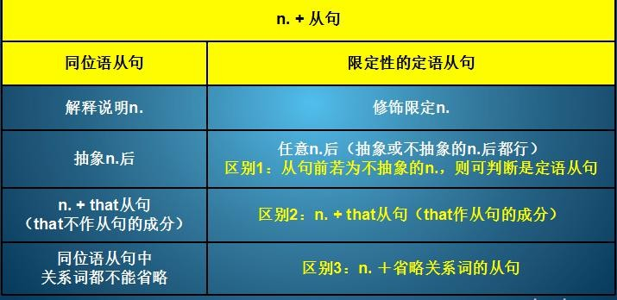

区别：

同位语从句

No one could account for the fact that one of the boxes was extremely heavy. No one could account for the fact that rocked the world.

同位语从句／定语从句？

It is one of the ugliest faces I have ever seen.

He became the proud owner of a bed which had springs and mattress.

定语从句

本课重点:

同位语从句：解释说明名词定语从句：修饰限定名词